**Database creation, Table Creation and Data Insertion**

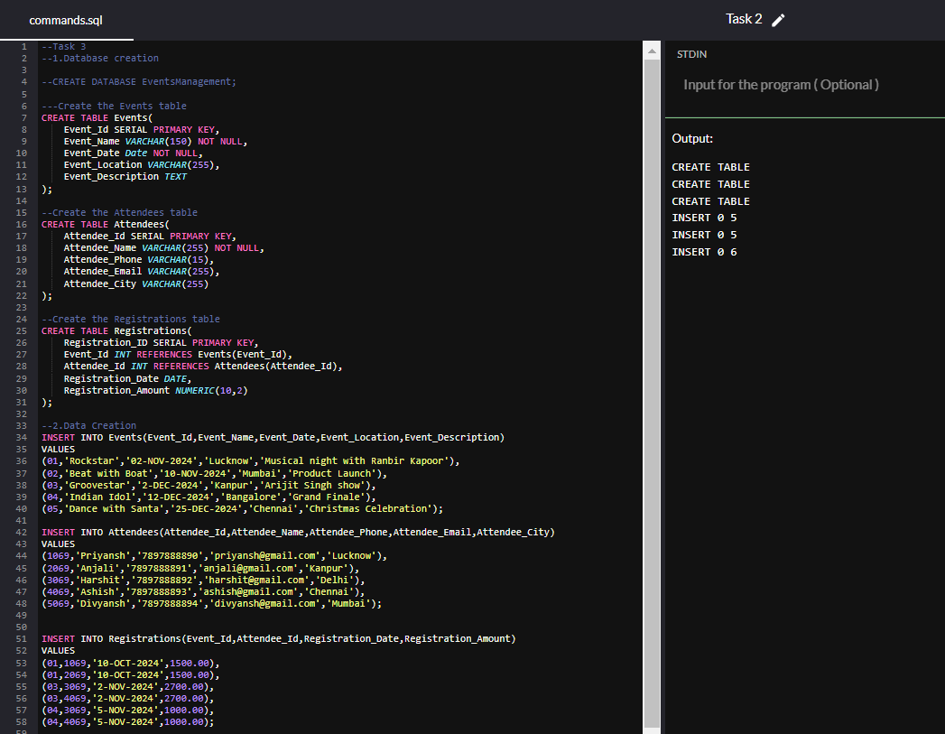

**3a. Inserting a new event.**

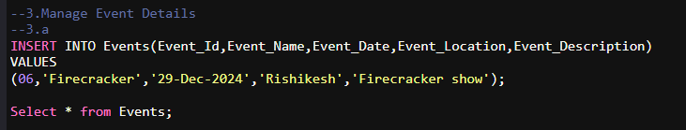

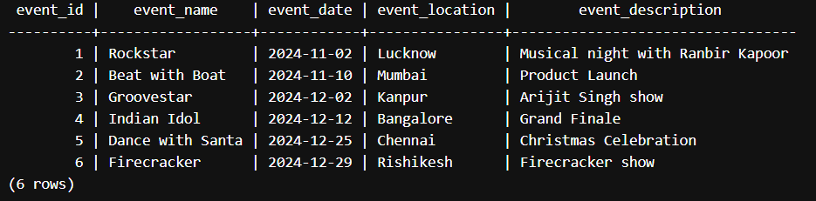

**3b. Updating an event's information.**

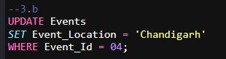

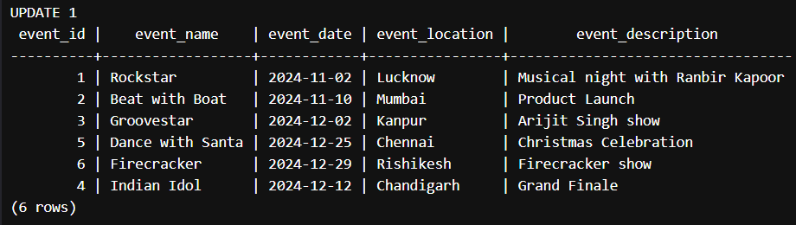

**3c. Deleting an event.**

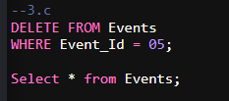

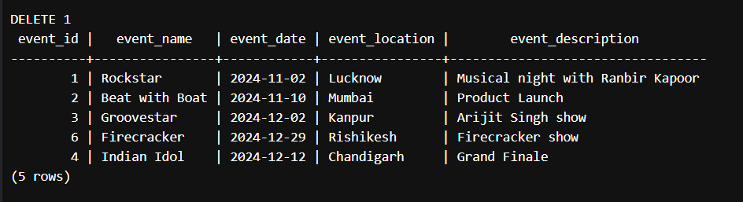

**4a. Inserting a new attendee.**

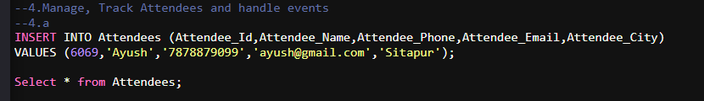

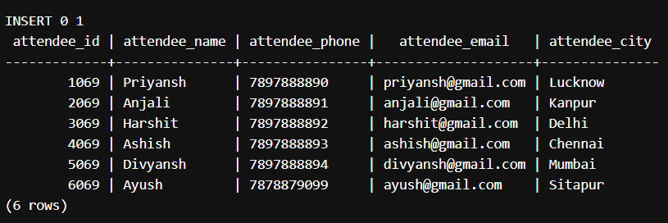

**4b. Registering an attendee for an event.**

